**SOSim User’s Manual v.2**

**A Guide to Operate the Subsurface Oil Simulator**

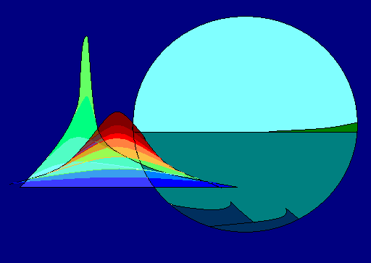

March 2020

Water Quality Engineering Laboratory

University of Miami

Miami, FL, USA

SINTEF Ocean

Trondheim, Norway

Gulf of Mexico Research Initiative (GoMRI)

# Preface

This User manual is a revision to the first edition**[1]**. SOSim (Subsurface Oil Simulator) is a 3-D public Bayesian probability model that infers and predicts subsurface oil movement based on field observations and prior data. SOSim v.1 was developed by Dr. Angelica Echavarria-Gregory at the Water Quality Engineering Laboratory (WQEL), James D. Englehardt, Director, University of Miami, in 2010. Version 1 was developed to help locate and forecast sunken oil trajectory on relatively flat bay bottoms based on limited field data after an instantaneous release. Now, SOSim has been further developed by Chao Ji and Mary Jacketti, WQEL, and Dr. CJ Beegle-Krause, SINTEF Ocean, Norway, to support instantaneous and continuous spills of sunken and submerged oil in coastal areas, and sunken oil in rivers.

This User Manual will guide you as the modeler in terms of model installation, model operation, and results management, to obtain maps of relative probabilities of finding subsurface oil within the area and date of your interest. All the functionalities described in this manuscript have been tested and verified.This research is part of the Inferential/Parametric Forecasting of Subsurface Oil Trajectory Integrating Limited Reconnaissance Data with Flow Field Information for Emergency Response project supported by the Gulf of Mexico Research Initiative Year 18-20 grants (RFP-VI).

Contents

Preface 2

CHAPTER 1 INTRODUCTION 5

**Welcome to SOSim** 5

**About SOSim** 5

**What SOSim can do** 7

**Getting and Installing SOSim** 8

**Hardware Requirements** 8

**Software Installation** 9

**How to Get What You Want from SOSim** 15

**Getting Help** 16

**How to Use This Manual** 16

CHAPTER 2 RUNNING SOSIM 17

**Learning the Basis** 17

**Introduction** 17

**Setting Up Your Scenario** 18

**Processing** 42

**SOSim Output** 44

CHAPTER 3 FOR DEVELOPERS 48

**SOSim Structure** 48

APPENDIX 50

# CHAPTER 1 INTRODUCTION

## **Welcome to SOSim**

Welcome to SOSim, the Subsurface Oil Simulator! This chapter contains an overview of SOSim, and a description of how to download and install SOSim from our Web site. This manual will guide you as you use SOSim.

## **About SOSim**

SOSim is a 3-D publicly available Bayesian probability model that infers and predicts subsurface oil movement based on the limited field observations at one or more sampling dates. The scope of subsurface oil includes sunken oil that resides on the bay or river bottom, or on continental shelves, and oil submerged in ocean water columns. SOSim is intended to be used during spill emergency response, to output a map of the probability of finding subsurface oil and the associated uncertainty in that trajectory. These probabilities can be interpreted as *relative oil concentrations*. Due to the lack of information on the total oil released as a function of time, the model cannot assess absolute concentrations, but rather relative concentrations showing oil “hotspots” and areas where oil may not be collecting. Uncertainty bounds indicate the potential extent of significant oil patches, generally more disperse than the field observations due to accounting for uncertainty in the advective and dispersive forces acting on the subsurface oil. **You can use SOSim to …**

* Locate and predict the possible locations of sunken oil on a bay bottom or continental shelf or river after an instantaneous or a continuous spill;
* Locate and predict the possible locations of submerged oil in the water-column below the thermocline in 3-D after an instantaneous or a continuous spill;
* Learn how the predicted trajectories and probability are affected by uncertainty;
* Guide oil responders to make sampling plans during emergency response.

To use SOSim, you are required to input information related to the spill into the SOSim graphic user interface (GUI). After SOSim is set up accordingly, the predictions showing the predicted trajectory of the oil spilled in your scenario will display on the SOSim GUI and also will be automatically saved under the SOSim program path folder. In contrast with other trajectory models, SOSim does not necessarily require hydrodynamic input data. **The required information includes …**

* The spill information: spill type, release type, spill location and spill time, oil type, and oil of concern (submerged oil or sunken oil);
* The campaign data file: field observations on oil locations and concentration.

**The optional inputs include …**

* Prior information:
* Sunken oil: bathymetry file in the form of spreadsheet data (.csv file) within the area of interest. However, if the user does not have a bathymetry file available, if the spill occurred in an ocean or river environment that connects to an ocean, the model can extract bathymetry data using the global ETOPO5 data file;
* Submerged oil: the output from OSCAR or other trajectory model on submerged oil distribution in NetCDF or spreadsheet format (.csv file).
* Users’ output options:
* Run SOSim with uncertainty calculations or not (corresponding to ‘*Minimum Regret*’ or ‘*Best Guess*’);
* Your knowledge of the ranges of the oil’s velocity and diffusion coefficients, or you can select the default ranges;
* Your options to display the outputs in latitude/longitude or in kilometers (distance from the southwestern most point in the modeling area);
* Your options to display the outputs in 2-D or 3-D (showing the isopycnal layer for the submerged model and the bathymetric and f/H contours for the sunken model);
* Your options to overlay the SOSim predictions with field observations or not.

## **What SOSim can do**

SOSim is a probabilistic model that can…

* Estimate the relative probability of finding oil in the area of interest by inference from the field data that you provide about the oil’s location and concentration.
* Estimate and predict the trajectory of the oil that results from the uncertainty in the probability distribution.
* Be updated quickly, and re-run to provide near real time predictions.
* Guide oil responders in developing sampling plans.
* Provide a probabilistic output (including uncertainty estimates) in a geo-referenced format.

## **Getting and Installing SOSim**

### **Hardware Requirements**

SOSim is publicly available via the internet and can be installed on both Macintosh and Microsoft Windows 32 or 64 bit. To achieve reasonable performance in terms of computational speed (hours), a 3.0 GHz processor or better is required. SOSim is written in Python with multiprocessing, so a multicore processor is preferred to make the code run faster. The program is 23.8 M. SOSim uses 15 threads during multiprocessing. If the user does not have a multicore computer (or has a computer with fewer cores), you will need to revise the ‘SOSimsubmerged.py’ or ‘SOSimsunken.py’ code to fit the capabilities of the computer. After opening the ‘SOSimsubmerged.py’ or ‘SOSimsunken.py’ code, the user can search (Ctrl+F) ‘mp.Pool(15)’. Then, you can change 15 to the number of cores you have or to 2 if you only have a single core computer. For example, if your computer is only a one core computer, then set to ‘mp.Pool(2)’.

SOSim can run on a computer with a page file (virtual memory) of minimum 2.3 GB. Nevertheless, it is recommended that the memory card is of a minimum of 3.0 GB. Memory requirements of SOSim are determined by the fact that Python can allocate memory only up to a total of 2.3 GB, including memory required for all machine functions prior to running the model, when implemented on the Windows 32 bit platform (this limitation is not expected if the model is developed in the future for the Windows 64 bit OS). The total memory used by all processes before running SOSim is typically about 512 MB on machines not having many applications installed and many idle processes to run by default, except for Windows 7 and some editions of Windows Vista which may consume up to 1 GB when idle. Therefore, for the majority of spill cases to be solved with optimal resolution and including recalculations, it is estimated that a computer would require an available memory of about 1.7 GB (that is, a difference of about 1.7 GB between the 2.3 GB limit and the kernel memory taken up by idle processes). Indirect warning messages provided by the GUI will guide the user in setting the best possible resolution to achieve optimal performance in terms of memory.

### **Software Installation**

Windows Computer

Python and all prerequisites of SOSim are included in the OSGeo4W console, a compilation of open-source packages developed by the Quantum GIS project. The OSGeo4W console is distributable and therefore is included with the SOSim package distribution. Steps required for the installation of SOSim are as follows. Note that additional advanced or updated installation procedures may be needed by a developer for future continued development of the Simulator.

1. Put the SOSim folder (<https://data.gulfresearchinitiative.org/data/R6.x812.000:0005>) in C:\Program Files\.
2. Run the ‘execute.psi’ file by clicking right mouse and choose ‘Run with PowerShell’. The program starts to download the Python and QGIS 2.14. After the QGIS is downloaded, click ‘Next’ to finish the installation process.
3. Add the below environment variables to your System variables,[2]

‘C:\Program Files\SOSim’ to ‘Path’;

‘C:\Python27’ to ‘Path’;

‘C:\Python27\Scripts’ to ‘Path’.

‘C:\Program Files\QGIS 2.14\bin’ to ‘Path’;

‘C:\Program Files\QGIS 2.14\apps\qgis-ltr\bin’ to ‘Path’;

‘C:\Program Files\QGIS 2.14\apps\grass\grass-7.2.2\lib to ‘Path’;

‘C:\Program Files\QGIS 2.14\apps\Python27\Lib\site-packages’ to ‘PYTHONPATH’;

‘C:\Program Files\QGIS 2.14\bin’ to ‘PYTHONPATH’.

‘C:\Python27\Lib\site-packages’ to ‘PYTHONPATH’;

‘C:\Program Files\QGIS 2.14\apps\Python27’ to ‘PYTHONPATH’;

‘C:\Program Files\QGIS 2.14\apps\Python27\lib\site-packages’ to ‘PYTHONPATH’;

­

‘C\Program Files\QGIS 2.14\share\gdal’ to ‘GDAL_DATA’

1. In the terminal, under the ‘C:\Program Files\SOSim’ path type ‘pip install -r .\requirements.txt’. After running this, all required packages are automatically installed.

**NOTE:** If you get an error when trying to run SOSim (e.g. an error about qgis.core), make sure to move up the variables you just created in ‘Path’ and ‘PYTHONPATH’ so they are at the top.

Now the SOSim software is ready to run using the following steps:

(1) type ‘execfile(‘c:\Program Files\SOSim\SOSimOPI.py’)’ in the Windows PowerShell;

(2) or open ‘SOSimOPI.py’ in Sublime Text, and press ‘Crtl+B’ to run the code.

Mac Computer

1. Download Python and QGIS 2.14. Python **(**>= 2.7**)** can be downloaded through <https://www.python.org/download/releases/2.7/> and QGIS 2.14 can be downloaded through <http://www.kyngchaos.com/files/software/qgis/QGIS-2.14.21-1.dmg> and installed in the Applications folder. Install from 1 GDAL Complete.pkg to 4 Install QGIS.pkg.

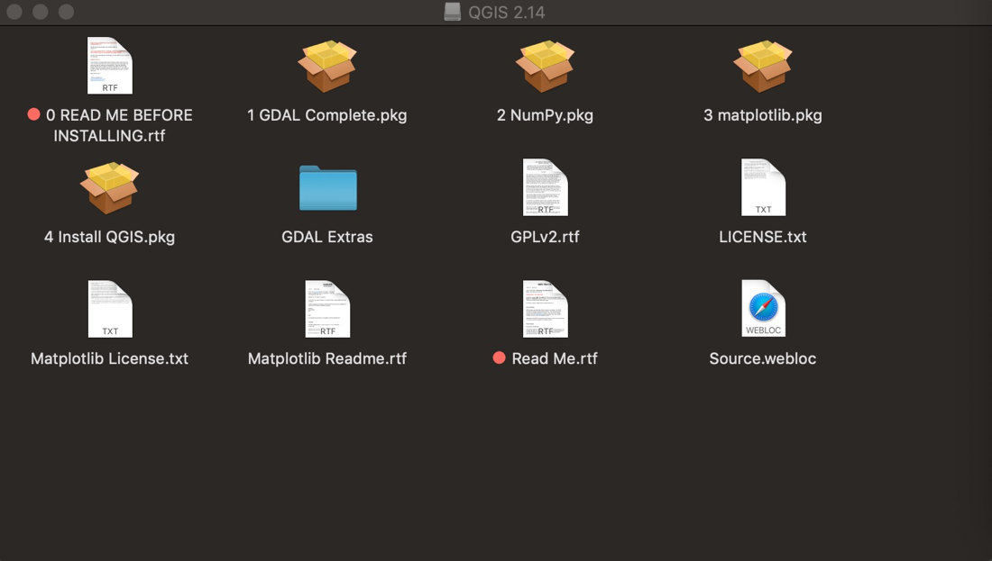

1. Put the SOSim folder (<https://data.gulfresearchinitiative.org/data/R6.x812.000:0005>) on your Desktop (or other directory).
2. Open the Terminal (which can be found in the spotlight search) and type:

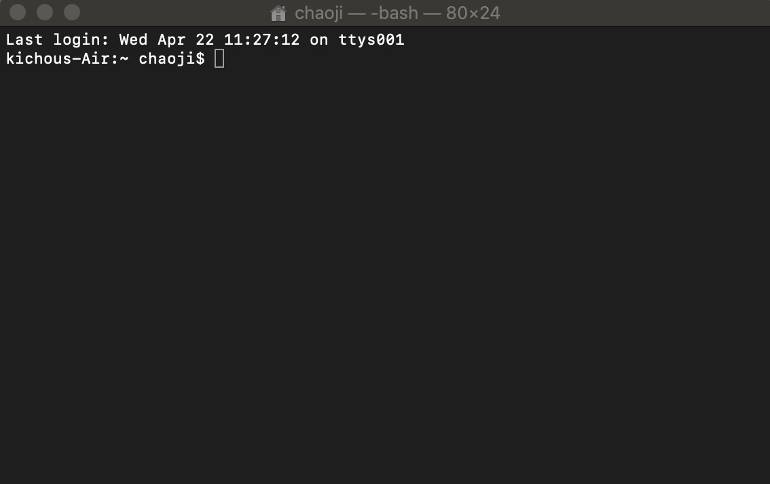

vim ~/.bash_profile[3] and then press Enter

Then, insert the following:

Export PYTHONPATH=/Users/(username)[4] /Desktop/SOSim/SOSim:/Applications/Qgis.app/Contents/Resources/python

export LD_LIBRARY_PATH=/Applications/Qgis.app/Contents/Resources/lib

export DYLD_LIBRARY_PATH=/Applications/QGIS.app/Contents/MacOS/lib/:/Applications/QGIS.app/Contents/Frameworks/

export QGIS_PREFIX_PATH=/Applications/QGIS.app/Contents/MacOS/

Then type :wq to exit. Then, still in the Terminal, type source ~/.bash_profile to update the environmental variables.

1. Open the Terminal (which can be found in the spotlight search) and type:

Now the SOSim software is ready to run using the following steps:

1. Open the Terminal and go to the directory of your SOSim folder. For example, if the SOSim folder is on your desktop, in the Terminal type:

cd Desktop/SOSim

Then press Enter. Now, you can type:

pip install -r requirements_mac.txt to install all required packages.

After it finished, you can type:

python SOSimOPI_Mac.py

And the GUI will open.

1. Or you can open ‘SOSimOPI_Mac.py’ in Sublime Text, and press ‘Command’ + ‘B’ to run the code.

## **How to Get What You Want from SOSim**

As you begin working with SOSim, you should experiment with the model to improve your skill and intuition in the way SOSim works. Create specific scenarios for training exercises or model demonstrations under different model inputs and output settings. We recommend that you include the ‘minimum regret’ (uncertainty) solution in your model runs all the time. The uncertainty estimates take the error into account and indicate the possible extent of contamination. This information allows responders to create more comprehensive response plans in which the value of a resource can be balanced against the probability that it may be impacted by the spill. Three example spills, the DBL-152 (DOI: [10.7266/n7-d7cg-md27](https://doi.org/10.7266/n7-d7cg-md27)) and the T/V Athos I spill (DOI: [10.7266/n7-8rhz-c860](https://doi.org/10.7266/n7-8rhz-c860)) for sunken oil and the DWH spill (DOI: [10.7266/n7-qsr6-gr54](https://doi.org/10.7266/n7-qsr6-gr54)) for submerged oil, are available at <https://data.gulfresearchinitiative.org/pelagos-symfony/data-discovery>. Those datasets include the input requirements, field observation file, prior files and the outputs. We recommend practicing using these three cases to get familiar with SOSim.

## **Getting Help**

The ‘Readme.txt’ file in SOSim covers the basic steps for installing SOSim. You can refer that as an assistant for installation. As you are using SOSim, each step has a warning to make sure you input the desired information. For example, in Figure 1.1, when you click ‘vessel release’, it will pop up with a warning to let you confirm your inputs. If you have any specific questions or you find any issues when running the code, you can contact Dr. James Englehardt at [jenglehardt@miami.edu](mailto:jenglehardt@miami.edu) or at 305-284-5557. Further contact information can be found at the end of the manual.

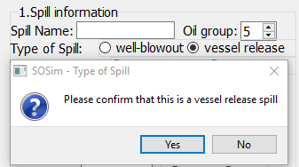

Figure 1.1. The warning information in SOSim

## **How to Use This Manual**

This manual includes four chapters to help you master SOSim. After the basic review in this chapter, turn to **Chapter 2** for a step-by-step tutorial. Refer to **Chapter 3** for the detailed explanations on the main features. **Chapter 4** provides model developers with the details on the model structure. If you want to sync part of SOSim to another interested model, this chapter will tell you how to find or change the code to fit their desires.

# CHAPTER 2 RUNNING SOSIM

## **Learning the Basis**

This chapter guides you, step-by-step, through a synthetic oil spill scenario describing both a sunken oil and submerged oil spill. Follow along, using your own copy of SOSim, to familiarize yourself with GNOME’s features and capabilities.

## **Introduction**

It is just at 22:00 pm, April 20, 2010, Coordinated Universal Time, your day began when you received a call a few minutes ago about an oil blowout in the deep ocean. Now you are going to the oil spill response office. Local Coast Guard officers are collecting some details about the spill from the field. You are asked to provide scientific information on the possible subsurface oil trajectory to support the Coast Guard and other members of the Unified Command.

Your colleagues have begun to compile the basic information that’s needed for the oil spill response:

* Marking the spill location,
* Collecting the field observations (several field data on submerged oil location and concentrations),
* Collecting the available subsurface predictions from trajectory models such as OSCAR, OILMAP, and GNOME,
* Collecting a bathymetry chart from the NOAA National Centers for Environmental Information or from another source.

As a modeler, you will use SOSim to estimate the possible trajectory of the spilled oil, to identify which areas could be affected by the moving and spreading oil.

## **Setting Up Your Scenario**

A SOSim GUI in Figure 2.1 will pop up after you run the SOSimOPI.py file. Required inputs are labeled from 1-7. The inputs will determine the model outputs. In particular, movement of the oil will be predicted based on relative oil concentrations at the field sampling points at and around the spill site, the time and location of the spill and of the samples collected. Other essential model inputs such as resolution, basic geographic information about the spill, extent of the modeling area, desired spatial resolution of the graphical output, and the dates at which predictions are desired determine output characteristics including run time. The GUI’s input area is organized according to functionality, as described below.

Figure 2.1. Main screen of SOSim, before starting a new project.

**Spill information**

Next, you need to input spill information in Figure 2.2 on ‘*Spill Name’*, ‘*Oil group’*, ‘*Type of Spill*’, ‘*Type of Release’*, ‘*release time’*, ‘*Oil of Concern*’, the spill time and the oil spill location at which the accident most likely occurred. This spill information is used to set the geographic system of reference for the run. The spill name is used for saving and distinguishing output figures and files. Oil group refers to the classification of oils into five generally accepted API classes by weight and other properties affecting their behavior in the environment. Spill type includes vessel release and well-blowout. Well-blowouts are often releases with pressure and vessel releases are often without pressure. SOSim regards a spill of duration less than 1 day as an instantaneous release, and a spill of duration longer than 1 day as a continuous spill. For an instantaneous spill, you need to input the spill start time. For a continuous spill, if the *‘Spill End’* is still unknown when you run the model (oil is still being released), you can input an estimated date that comes after the field observations. The estimated date will not change the SOSim output if the prediction date is before the end of the spill. The longitude and latitude should be entered in decimal degree coordinates.

After inputting the spill information, the world map screen will zoom in to the detailed map around the spill location in Figure 2.3. The spill location is represented as a red cross on the world map. The *‘Global Area’* is a smaller version with a larger scale, and you can scroll your mouse to zoom in and zoom out on the map.

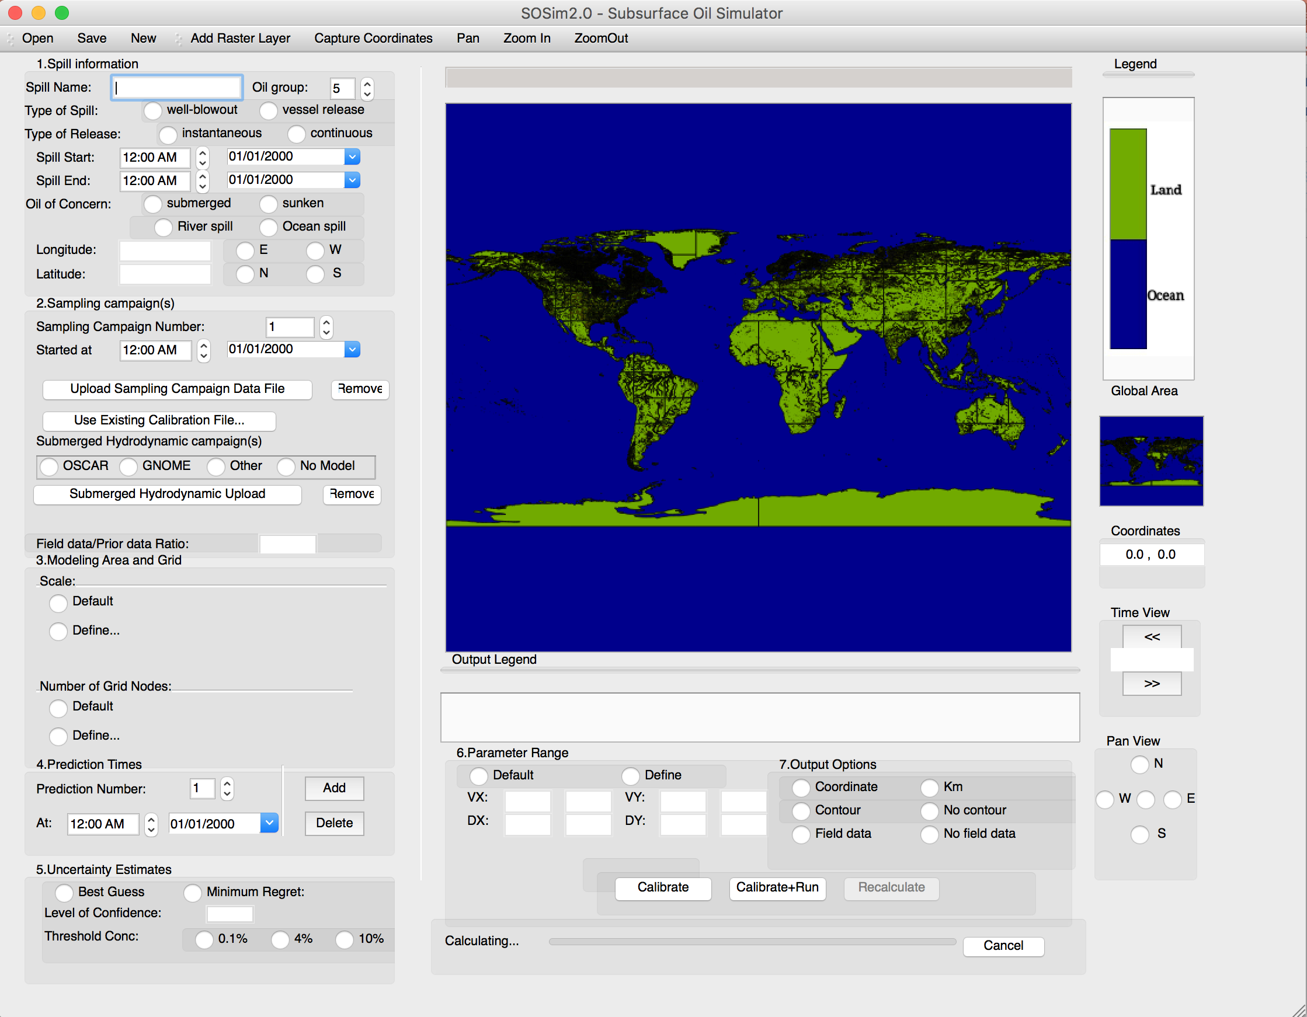

Figure 2.2. Spill Information input prompts in SOSim GUI

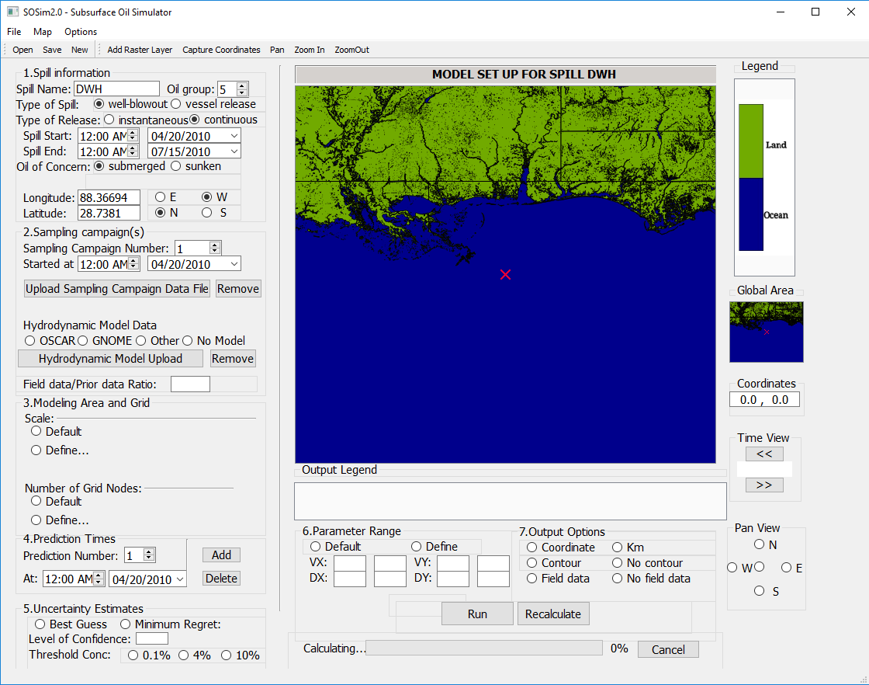

Figure 2.3. Main screen of SOSim, after inputting the spill information.

The detailed definition of the variables:

* *‘Spill Name’*: allows the user to set the title of the spill, e.g. “DBL-152”. Characters /, \, *, <, >, “, | and ? are not accepted but blanks between words are recognized. If a change in typed input is required, an informational message will pop up after all inputs to the Spill Information panel have been entered;
* ‘*Oil group’*: Consistent with current spill response practice, SOSim recognizes 5 basic groups of oil. Group 1 represents non-persistent light oils such as gasoline and condensate. Group 2 represents persistent light oils such as diesel, No. 2 fuel oil and light crudes. Group 3 represents medium oils such as most crude oils and IFO 180. Group 4 represents heavy oils such as heavy crude oils, No. 6 fuel oil and Bunker C oil. Group 5 represents sinking oils such as slurry oils and residual oils.
* ‘*Spill start’* and ‘*Spill end’*: set the spin box to the time at which the most significant oil loss occurred. Notice that you can edit the hour and minutes using either the mouse cursor or the arrows of the spin box, or both. Then, set the day, month and year of the spill using the smart calendar that pops up when you click in the drop-down menu located to the right. The date line edit can also be changed manually using the mouse cursor and the keyboard.
* *‘Longitude’*: this line prompts for a quantity in decimal degrees (WGS) corresponding to the longitude coordinate at which the spill occurred. All quantities must be greater than zero and must have decimal figures that can be zero (e.g. 93.0 instead of 93). After the prompt the user shall select the button “E” (longitude east) or “W” (longitude west), which will assign a direction to the quantity you typed and will guide the canvas to the world’s geographic meridian closest to the longitude of the spill site.
* *‘Latitude’*: this line prompts for a quantity in decimal degrees (WGS) corresponding to the latitude coordinate at which the spill occurred. All quantities must be greater than zero and must have decimal figures that can be zero (e.g. 29.0 instead of 29). After the prompt, select the button “N” (latitude north) or “S” (latitude south), which will assign a direction to the quantity you typed and will guide the canvas to the world’s geographic parallel closest to the latitude of the spill site, and will mark the spill site with an X (See Figure 2.3 for an example).

The following conditions apply to the Spill Information input section:

* Only a point source spill occurring at a pair of coordinates (in degrees of longitude and latitude) can be modeled;
* If you wish to modify the spill name at this point, you would have to proceed with the change and then repeat the last step *‘Latitude’*.

**Sampling campaigns**

Next, you need to upload the sampling campaigns. To upload each sampling campaign file, make use of the prompts and buttons in the ‘*Sampling Campaign(s)*’ panel of the GUI in Figure 2.4.

SOSim infers the oil’s movement based principally on the relationship between the location and time of the spill, and the locations and concentrations at subsequent sampling times. For purposes of SOSim input, a sampling campaign is defined as a set of quantitative measurements of oil concentration on the bottom or in the water column, taken at approximately the same time. Spill and sample coordinates are entered in WGS (World Geodesic System) units (decimal degrees of longitude and latitude). Time differences from sampling point to point of up to a few hours do not need to be considered, as the model was not designed to track possible cyclic excursions of the oil due to the tidal cycle. The field data detected on the same day but at different hours are regarded as data that are sampled on the same day.

Click ‘*Upload Sampling Campaign Data File*’, and you can upload all the field observation files you have to SOSim.

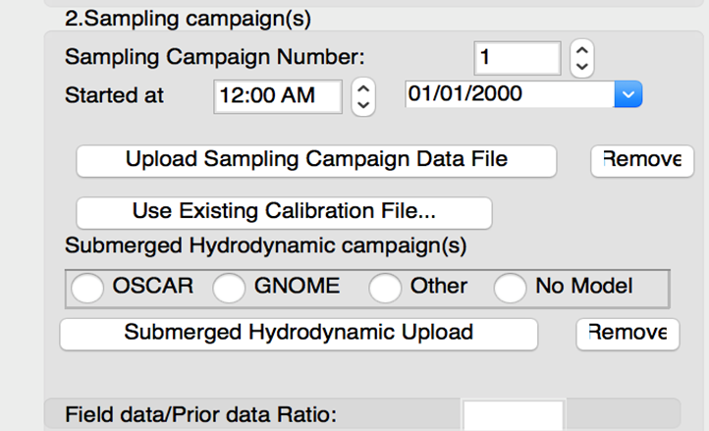

Figure 2.4. Sampling Campaign input prompts and buttons in the GUI.

The following descriptions and conditions apply to the buttons in Figure 2.4:

* *Sampling Campaign Number*: adjust the number in the spin box to that of the sampling campaign that you want to upload and process. A campaign number greater than 10 is not accepted (e.g. after uploading the first sampling campaign file, change the Sampling Campaign Number to 2);
* *Start at: Time, Date:* set the spin box to the time representing the midpoint of the sampling campaign. Note that you can edit the hour and minutes by using either the mouse cursor or the arrows of the spin box, or both. Set the day, month, and year of the sampling campaign using the smart calendar that pops up when you click in the drop-down menu located to the right. Notice that the date line edit can also be changed manually with the mouse cursor. It is not necessary that the dates of previously uploaded campaigns have earlier sampling dates than the campaign currently being uploaded, but the dates of all sampling campaigns must be subsequent to the spill date entered and subsequent to the assessed retardation gap, during which oil may be still sinking depending on its type. A warning message will guide you in case of an error. Sampling dates of different campaigns can even be the same (different response teams can take samples in different areas at the same time). Nevertheless, it is recommended that sampling be conducted at different times in order for the model to better account for changes in subsurface oil movement. Also, data with different dates may be located in one sampling campaign file. When uploading this file, the day, month, and year should be set to the earliest sampling date. In the code, all sampling dates will be processed.
* *Upload Sampling Campaign Data File* button: this button opens an explorer dialog box that allows you to browse for your *“.csv (comma-separated values)”* Excel file containing the sampling campaign information which you want to upload. It is recommended that every sampling campaign file have a different name and be identified with a number. If the sampling campaign entered happens to be during the assessed sinking retardation time, the sampling campaign will be invalidated, and a warning issued.
* *Remove Sampling Campaign* button: this button automatically removes from the record the data of the campaign that corresponds to the current number in the *Sampling Campaign Number* spin box. A confirmation message pops up to confirm the deletion, along with the number of the sampling campaign that was removed. However, deletion of the file does not change the numbers of any other uploaded campaigns, so that there will now be a campaign number with no assigned data.

The sampling campaign format must be in a spreadsheet in the form of a ‘.csv’ file, closely following the instructions below.

A field campaign example for the submerged oil model is in Figure 2.5a. A field sample campaign example for the sunken oil model is in Figure 2.5b.

* The spreadsheet has 5 columns for the submerged oil model. The spreadsheet only has 4 columns for the sunken oil model.
* The title (field name) for each column must be the same as the title as given in Figure 2.5 and included in the first line of each column.
* In Column A, enter the longitude coordinate, in decimal degrees, at which the sample was collected, starting on line 2.
* In Column B, enter the latitude coordinate, in decimal degrees, at which the sample was collected, starting on line 2;
* In Column C, enter the total concentration. If quantitative measurements are available, measurements in the unit of ppb can be entered with accuracy of up to several decimal places. If the concentration data are for sunken oil (e.g. collected from VSORS, snare samplers or poling data) and are measured as relative oil concentrations on a relative scale of range scale of 0 – 100 (that is, enter a percentage of oil without the percent sign), starting on line 2. Also, for sunken oil, if the concentration data are represented as none, low, medium, high concentration, convert these qualitative estimates to relative oil concentrations from 0-100. The model will provide more accurate results with more quantitative concentration data.
* In Column D, enter the SampleTime, in the form of ‘yyyy-mm-dd hh:mm:ss’, starting on line 2. This is the last column needed for the sunken oil model;
* For the submerged model, in Column E, enter the depth, in meters, at which the sample was collected, starting on line 2.

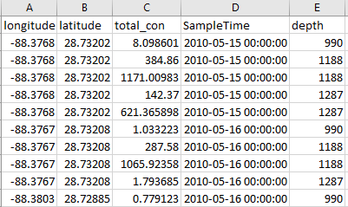

Figure 2.5a. Sampling campaign(s) example (submerged oil model).

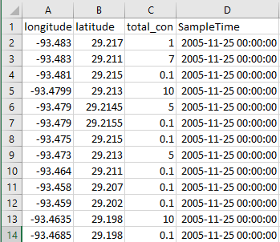

Figure 2.5b. Sampling campaign(s) example (sunken oil model).

**Prior information**

Next, you can upload the prior information, which is optional. The hydrodynamic model results are prior information for submerged oil and the bathymetric data are the prior for the sunken oil model. If there is no prior information, click ‘No Model’ or ‘No Upload’.

* **Submerged oil**

To upload each prior information file (e.g., OSCAR output), make use of the prompts and buttons in the ‘Submerged Hydrodynamic campaign(s)’ panel of the GUI in Figure 2.6.



Figure 2.6. Submerged Hydrodynamic Campaign(s) input prompts and buttons in the GUI.

SOSim accepts the outputs from OSCAR, GNOME and other models. The outputs from OSCAR and GNOME are required in the form of NetCDF and the other models’ outputs are required to be saved as a ‘.csv’ file. The variables in OSCAR NetCDF file should include ‘longitude’, ‘latitude’, ‘depth’, ‘time’, ‘total_concentration’, ‘concentration’, and ‘bathymetry’. The shape for ‘longitude’, ‘latitude’, ‘depth’ and ‘time’ is one dimension. The shapes of ‘total_concentration’ and ‘concentration’ are four dimensions. An example is in Figure 2.7.

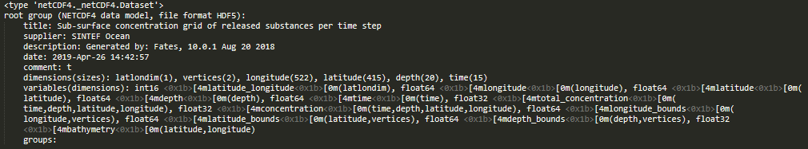

Figure 2.7. OSCAR NetCDF file example

The variables in GNOME NetCDF file should include ‘longitude’, ‘latitude’, ‘particle_count’, ‘surface_concentration’, ‘time’ and ‘depth’. An example is in Figure 2.8. The shapes for all the variables are one dimension.

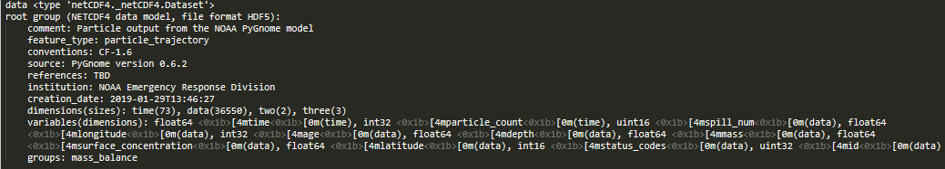

Figure 2.8. GNOME NetCDF file example

The required information in the ‘.csv’ file includes the ‘lat’, ‘lon’, ‘depth’, ‘predicttime’ and ‘concentration’, closely following the instructions below. A prior campaign example is in Figure 2.9.

* The spreadsheet has 5 columns.
* The title (field name) for each column must be the same as the title as given in Figure 2.5 and included in the first line of each column.
* In Column A, enter the longitude coordinate, in decimal degrees, at which the sample was collected, starting on line 2.
* In Column B, enter the latitude coordinate, in decimal degrees, at which the sample was collected, starting on line 2;
* In Column C, enter the total concentration. If quantitative measurements are available, measurements in the unit of ppb can be entered with accuracy of up to several decimal places.
* In Column D, enter the prediction time, in the form of ‘yyyy-mm-dd hh:mm:ss’, starting on line 2;
* In Column E, enter the depth, in meters, at which the sample was collected, starting on line 2.

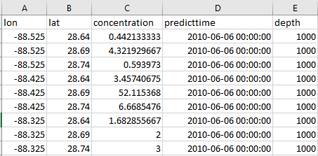

Figure 2.9. ‘Other’ models file example

A parameter ‘Field data/Prior data Ratio’ is defined to represent your confidence in the prior results. If you are more confident in your prior information as to the submerged oil’s location, you should select a ratio less than 1. If you are more confident in your field observations as to the location of the submerged oil, you should select a ratio greater than 1. If you have no bias towards either information source, select a ratio equal to 1.

* **Sunken oil**

To upload each prior information file, make use of the prompts and buttons in the ‘Bathymetric Data’ panel of the GUI in Figure 2.10.

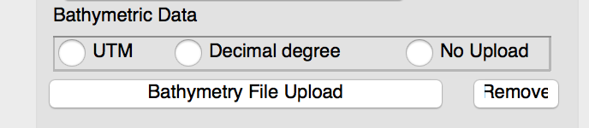

Figure 2.10. Sunken Bathymetric Campaign input prompts and buttons in the GUI.

SOSim accepts bathymetry data in the form of a ‘.csv’ file. The latitude and longitude coordinates can be input as UTM or decimal degrees. If the coordinates are in the form of UTM, select the ‘UTM’ button and if they are in the form of decimal degrees, select the ‘Decimal degree’ button. If the user does not have access to a bathymetry file, they can select the ‘No Upload’ button. If the ‘No Upload’ button is selected and the oil spill occurred in an ocean or a river that connects to an ocean, SOSim will extract bathymetry data from a global ETOPO5 data file.

Follow the instructions below closely to create the bathymetry data file. A prior campaign example is in Figure 2.11a for ‘Decimal degree’ and Figure 2.11b for ‘UTM’.

* The spreadsheet has 3 columns.
* The title (field name) for each column must be the same as the title as given in Figure 2.11a or Figure 2.11b and included in the first line of each column.
* For ‘Decimal degree’, in Column A, enter the longitude coordinate, in decimal degrees, at which the sample was collected, starting on line 2. For ‘UTM’, in column A, enter the Easting coordinates, starting on line 2.
* For ‘Decimal degree’, in Column B, enter the latitude coordinate, in decimal degrees, at which the sample was collected, starting on line 2. For ‘UTM’, in column B, enter the Northing coordinates, starting on line 2;
* In Column C, enter the depth of the waterbody at that location. The depths should be negative. These depths can be recorded to several decimal places.

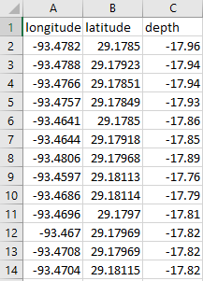

Figure 2.11a. Decimal degree bathymetry file example

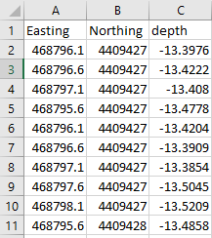

Figure 2.11b. UTM bathymetry file example

A parameter ‘*Field data/Prior data Ratio*’ is defined to represent your degree confidence in the prior information relative to the field concentration data, as related to the location and trajectory of sunken oil. If you are more confident of the sunken oil’s location based on the prior information, you should specify a ratio less than 1. If you are more confident that the field observations portray the location of the sunken oil, you should specify a ratio greater than 1. If you have no bias towards either information source, specify the ratio as equal to 1.

**Modeling Area and Grid**

The next step is to define the modeling area and grid (prediction resolutions).

The modeling area is the geographical area over which the user wishes to predict oil locations in time. The grid is a set of orthogonal points in the west-east and north-south directions defined on a Cartesian plane, representing the area to be modeled. Results of the prediction are calculated and plotted at every node in the grid. The more nodes requested in each direction, the better the spatial resolution of the mapped output and the longer the run time. These characteristics are entered in the panel ‘*Modeling Area and Grid*’ shown in Figure 2.12:

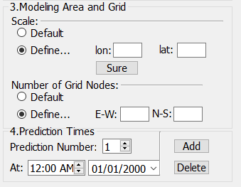

Figure 2.12. Modeling Area and Grid input prompts and buttons in the GUI.

The following descriptions and conditions apply to the buttons in Figure 2.12:

* The *‘Modeling Area and Grid Scale’*: the *‘Default’* button automatically zooms in and selects a region of 0.2° degrees longitude by 0.2° degrees latitude around the spill site (approx. 22 by 22 km or approx. 13.67 by 13.67 miles). This feature can be used along with the post processing *‘Recalculate’* when the user plans to consecutively run SOSim for contiguous geographical regions of the same size. The *‘Defin*e’ button requires the user to type in the modeling area, such as ‘lon: 0.4’, and ‘lat: 0.4’.
* ‘*Number of Grid Nodes’*: the ‘*Default’* button, assigns 25 nodes in the west-east and north-south directions. SOSim will divide the longitude and latitude into 25 parts. Under the default scale and grid, the longitude resolution is 0.016° and the latitude resolution is 0.016°. The other is the *‘Define’* button for the user to assign equal or different numbers of east-west and north-south nodes. Any number of grid nodes greater than 25 will increase the resolution of the model.
* *‘View Default Settings’*: To view the default input, go to the ‘*Options’* menu of SOSim and click on ‘*Default Settings’*. Click each tab to view the default values that are used to run SOSim, as shown in Figure 2.13.

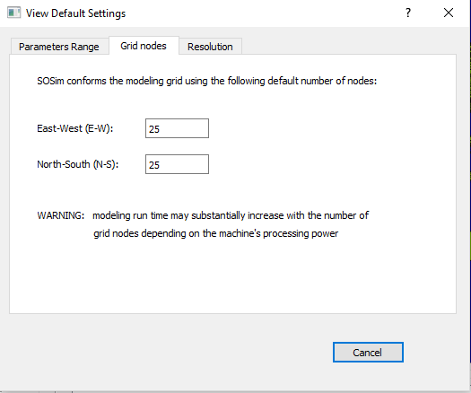

Figure 2.13. Modeling Default Setting prompt in the GUI.

**Prediction Time**

In order to enter these times, all previous input sections must be completed. An error message pops up if input information is missing. Projection times are the dates and hours the user wishes to view predicted subsurface oil relative concentrations. The user can request up to five prediction times per model run. However, computational run time will be longer for each projection time requested, and it is recommended that one prediction be modeled at a time, with the aim to plan and make timely decisions about subsequent run needs. Times are input to the panel shown in Figure 2.14.

You can input several prediction times and click ‘*Add*’. If you want to delete the existing prediction time, click ‘*Delete*’.

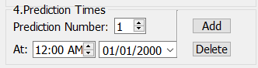

Figure 2.14. Prediction Times input buttons in the GUI.

The following descriptions and conditions apply to the buttons in Figure 2.12:

* *Prediction number* spin box: Assign a whole number index to each desired time of prediction. If the index number is not changed in the spin box when adding a new date and hour, a warning message will appear;
* *At*  hour spin box and date prompt: Complete these fields with, respectively: (a) the hour, including minutes if desired, and (b) the date, from the smart calendar pop-up, at which predictions are desired. The user must confirm final entry by clicking the ‘*Add’* button;
* *Add* button: Add the current hour and time to a list of prediction times and assign it to the index position indicated by the *‘Prediction number’* spin box. Any prediction time before most current sampling campaign date cannot be modeled as the likelihood function is affected by all sampling campaigns. A message will appear requesting that only sampling campaigns prior to the requested prediction time be on file. However, if only one sampling campaign file is uploaded with several sampling dates, and the prediction time is after the earliest sampling date and before the final date, the model will be able to run.
* *Delete* button: If desired, you can use this button to cancel the addition of the prediction time that corresponds to the current value in the *‘Prediction number’* spin box. If a prediction time is deleted by mistake, the hour and date can be added using a different, new index or *‘Prediction number’*.

**‘Best Guess’ or ‘Minimum Regret’**

The next step is to choose the way you want to calculate the oil’s distribution, with or without uncertainty estimates in the ‘*Uncertainty Estimates’* panel. *‘Best Guess’* represents the SOSim predictions without uncertainty. *‘Minimum Regret’* represents the SOSim predictions with uncertainty bounds. We recommend that you include ‘*Minimum Regret’* (uncertainty) solution in your model runs all the time. The uncertainty estimates take the experimental error and lack of complete information into account and provide an estimate of the possible extent of oil contamination. In the uncertainty estimate scenario, you need to define the level of confidence and ‘*Threshold Conc*’.

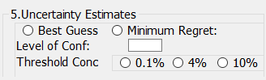

Figure 2.15. Uncertainty Estimates buttons in the GUI.

The following descriptions and conditions apply to the buttons in Figure 2.15:

* *‘Best Guess’* button: Under ‘*Best Guess’*, SOSim provides results give the maximum likelihood.
* *‘Minimum Regret’* button: Under the ‘*Minimum Regret*’, SOSim provides results with uncertainty. The uncertainty is shown in SOSim results to represent the total possible affected oiled area, for example, the area which we are 95% confident contains all oil of concentration 4% or greater.
* *‘Level of Conf’*: Enter the level of confidence in the range from 0 to 1. For example, if you want to calculate 95% confidence bound, you input 0.95 at the blank space.
* *‘Threshold Conc’*: The ‘*Threshold Conc*’ represents the threshold relative concentration that is shown on the SOSim results. The optional relative concentration levels are ‘0.1%’, ‘4%’ and ‘10%’, representing the relative probability of finding subsurface oil.

If the user selects *‘Recalculate’,*  the *‘Minimum Regret’* solution can only be run if the *‘Minimum Regret’* solution was also run when the user selected *‘Run’*.

**Parameter Range**

The parameter range corresponds to internal parameter ranges that may be modified by an expert in oceanography or Bayesian modeling with the aim of optimizing the precision and accuracy of the prediction based on changes in the conditions of the modeling scenario or the specifics of a known situation given the occurrence of an oil spill. The default input may be modified every time SOSim is launched if the default ranges need to be changed. SOSim provides two options: *‘Default’* and *‘Define’* in Figure 2.16. The default parameter ranges are in Figure 2.17. These parameter ranges account for conditions in all ocean waterbodies. For sunken oil, SOSim’s default parameter ranges in river settings differ from the default ranges in oceanic settings. To view the Parameter Range default, go to the ‘*Options’* menu of SOSim and click on ‘*Default Settings’*. Click the ‘Parameters Range’ in the tabbed widget to view the default settings. For a river spill, the velocity range is -67.1 to 67.1 and -2.4 to 2.4 km/d in the x and y directions and the diffusion coefficient is 0.01 to 0.6 and 0.01 to 0.2 km2/d in the x and y directions. When using the ‘*Define’* setting as seen in Figure 2.16, you can define the velocity and coefficient of diffusion based on the available information.

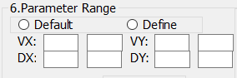

Figure 2.16. Parameter Ranges panel in GUI

The following descriptions and conditions apply to the buttons in Figure 2.16:

* *‘Default’*: When ‘*Default*’ is clicked, the ‘VX’, ‘VY’, ‘DX’ and ‘DY’ boxes will disappear. The user can view the values of the default parameter ranges by clicking ‘*Options’* and then clicking ‘*Default Settings’*. SOSim will use the default values in Figure 2.17 when running the model. In Figure 2.17, the first number in each box represents the default values used for the submerged oil model. The numbers in the parentheses represent the default values used for the sunken oil model for ocean spills. The boxes with only one number represent the same default value used for both the sunken and submerged models.
* *‘Define’*: When ‘*Define*’ is clicked, the ‘VX’, ‘VY’, ‘DX’ and ‘DY’ boxes will appear. ‘VX’ and ‘VY’ are velocity in x and y directions. ‘DX’ and ‘DY’ are diffusion coefficient in x and y directions. The units of ‘VX’ and ‘VY’ are km/d, and the units of ‘DX’ and ‘DY’ are km2/d. For example, the blank box closest to the ‘VX’ label represents the minimum parameter value for the velocity in the x direction and the blank box furthest from the ‘VX’ label represents the maximum parameter value (Figure 2.16).

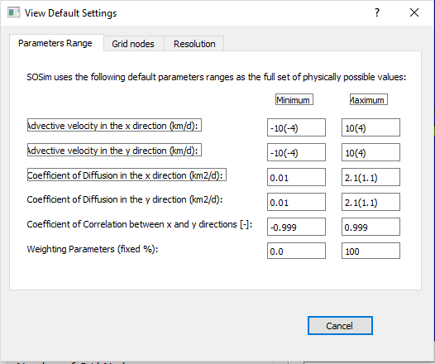

Figure 2.17. Modify default input settings dialog box.

**Output Options**

The output options are the last segment of required input. The output options allow the user to tailor the display to present the desired model outputs. You can choose to display the output in latitude-longitude (Coordinate) or in km scale (Km). ‘*Contour*’ will display the results in 3-D with the depths of finding subsurface oil in the results (as well as the f/H contours for the sunken oil model). ‘*Field data*’ are the model inputs and include the field observations (and sampled prior data for the submerged oil model). You can choose whether to display the field data and contours or not.

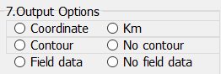

Figure 2.18. User Output Options panel

The following descriptions and conditions apply to the buttons in Figure 2.18:

* *‘Coordinate’ and ‘Km’*: *‘Coordinate’* will display the predictions in global latitude and longitude. If the scale is changed from the Default Scale, the output will be slightly shifted on the GUI due to the flattening of the world map[5]. The output will also be saved to the ‘*Results*’ folder in your SOSim folder on your desktop and will be displayed correctly.
* *‘Km’: ‘Km’* will display the predictions as the distances away from the bottom left corner of the prediction area. Due to the map in the GUI using the global latitude and longitude coordinate, the output in ‘*Km*’ cannot be displayed in the SOSim GUI, but the output in ‘*Km*’ will be saved to the ‘*Results*’ folder in your SOSim folder on your desktop.
* *‘Contour’ and ‘No Contour’:* When you click the *‘Contour’,* SOSim predictions in 3-D will contain the predicted depths of finding oil. With ‘*No Contour*’, the SOSim predictions are in 2-D showing the horizontal distributions of the subsurface oil.

## **Processing**

This section describes operation of the model after the input information is complete and before the outputs are generated. Output can be (1) only a calibration file to be saved for further processing, (2) a calibration file plus map predictions for requested scenarios based on the last, or (3) recalculations based on previous predictions and a saved or recently created calibration file. Figure 2.19 shows the processing buttons of the GUI.



Figure 2.19. Processing buttons

**Run and Recalculate Buttons**

After setting up all the inputs, the model is ready to run. Click the ‘*Run’* button to run SOSim. In addition, the model processing includes and *‘Recalculate’*. The *‘Recalculate’* button should only be pressed after the model has been run while the GUI is still open once before.

The following descriptions and conditions apply to the buttons in Figure 2.19:

*‘Run’* button: this button is used to instruct SOSim to first calibrate the model using the sampling campaign files and then immediately begin computations for prediction. This button is intended to obtain the results of a complete scenario by investing time in only one initial configuration. Overnight calibration-and-runs sessions are possible using this button. No changes to the input are allowed at this point until the core module has completed the Bayesian processing stage.

*‘Recalculate’* button: this button has several uses. First, the button may be used to generate results for the same spill scenario at a different time prediction, without data entry and recalibration. Pressing this button instead of the ‘*Run*’ button will instruct SOSim to use previous input information regarding the sampling campaigns and the spill and will require much shorter runtime than would be required to rerun the case from scratch using the ‘*Run*’ button. Second, the button may be used to obtain a new prediction following a change in resolution, boundaries, or geographical area (post processing and optional output), again without additional data entry or recalibration. The *‘Recalculate’* button will not work if the model is first run using the *‘Run’*  button without computing the ‘*Minimum Regret*’ (uncertainty estimate) solution and the user wants to compute the ‘*Minimum Regret*’ solution by pressing the *‘Recalculate’* button. The uncertainty estimate must also be calculated during the first model run.

**Run Time and Progress Bar**

Under the default condition, in general, the run time is ~ 4 hours. The run time increases if (a) the cores for multiprocessing decreases, (b) the number of prediction times increase, (c) the number of field observations increases and (d) the number of output nodes increases. The progress bar in Figure 2.20 indicates the total complete percent.



Figure 2.20. Progress bar

## **SOSim Output**

When SOSim uses 15 threads during multiprocessing, the model will be expected to take 4-6 hours to run (with uncertainty estimates).These run times will be greater (6-10 hours) for computers with less cores. It should be noted that the model will take longer to run with more field data. Output is produced as a map representation of predicted relative oil concentrations within the modeling area. There are two classes of output: the default and the optional output.

**Default Output**

The map at the first requested time of prediction is automatically displayed in the GUI canvas immediately after the processing stage is completed. In addition, a portable raster map (PNG format) of this result is saved in the ‘*Results*’ folder in your SOSim folder on your Desktop. If more than one time of prediction was initially requested, map results corresponding to all prediction times will be available for the user to display on the canvas and save to disk, as the user requests with the “*<<*” and “*>>*” buttons located to the right of the display. ‘<<’ represents the previous outputs and ‘>>’ represents the next outputs.

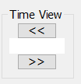

Output maps are the color-coded probability maps that are normalized from 0-1. The probability is the relative probability of finding oil. Also, total subsurface oil masses are not known as a function of time. In fact, although relative concentrations may decrease with time due to oil dispersion, total subsurface oil mass may simultaneously be changing due to sinking and re-suspension. Therefore, colors are not related from one time of prediction to another (that is, the same colors in different maps do not indicate the same relative concentration values or probability of finding oil). Rather, a scale of dark yellow to dark purple is presented at each time, indicating relative spatial probabilities of finding subsurface oil at each time independently. The same interpretation applies whether individual prediction times are requested as part of the same run or in separate runs. It should be noted that the internal calculations of SOSim assume a constant total oil mass in time. However, this assumption does not affect model output.

**Optional Output**

Optional output includes map results for areas that are close to the current modeling area, zoomed-in within the current modeling area to have a detailed area, or zoomed-out to include a larger area. Optional output is obtained as follows.

To move the SOSim results contiguous to a current output map:

* Under the section ‘*Pan View*’, select the direction to which you desire to move. The button ‘N’ will move the displayed output northward by the map scale, ‘S’ will move the displayed output southward by the map scale, ‘W’ will move the displayed output westward by the map scale, ‘E’ will move the displayed output eastward by the map scale, and the center button will move the output back to the center. For example, if the desired new modeling area is the continuation of a coastal region that extends to the north, select the button “N” under the ‘*Pan View*’ section.

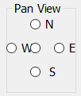

* The ‘*Pan*’, ‘*Zoom In*’ and ‘*Zoom Out*’ tool under the ‘*Map*’ toolbar also works to change your view the results;

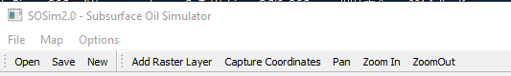

**Recalculate**

If you want to re-calculate the subsurface oil distribution with new scales, re-input the modeling area and press the ‘*Recalculate*’ button. Pressing this button instead of the ‘*Run*’ button will instruct SOSim to use previous input information regarding the sampling campaigns and the spill information, which will require much shorter runtime than the runtime would be required to rerun the case from scratch using the ‘*Run*’ button.

If you want to update predictions based on new or revised sampling campaign data:

* If a sampling campaign is no longer needed or requires revision, remove it using the ‘*Remove Sampling Campaign*’ button, making sure to select the correct campaign number from the drop-down menu; upload the new sampling campaign data as usual; and
* If the modeling area, resolutions and prediction times are not to be changed, then press the ‘*Run*’ button. The ‘*Recalculate*’ button is not useful in this case because the model run must be computed from scratch using the new field data, conserving only the desired prediction date(s), areas, and initial spill information.

**Post Processing**

Post processing includes creating a new case study by ‘*New*’, uploading previous raster output for viewing in a GIS (geographic information system), saving output, saving calibration files for further use, and printing images. The post processing tools are located in the ‘*Map*’ toolbar of the GUI.



# CHAPTER 3 FOR DEVELOPERS

## **SOSim Structure**

SOSim is written in four main modules: the graphical user interface (GUI) module, the operating and processing interface (OPI) module, one core module for submerged oil simulation and the other core module for sunken oil. The GUI module (SOSimgui.py file) automatically lays out and retains characteristics of widgets, labels, canvases and templates in the graphical user interface, retains raw user input, and imports Windows palettes and display. The OPI module (SOSimOPI.py in the SOSim source code) is the executable file. It imports and links all other modules, captures input information entered by the user in the GUI module, and operates interrelated buttons and activities of the GUI; it filters, organizes, and processes the input; passes ready-to-use variables and attributes to the core code; accepts modeling results back from the core module; processes the results; and sends display signals to the canvas layout of the GUI module to allow it to depict relative sunken oil concentrations on a map for further user interaction. It also controls modal behavior of the main windows, pop outs, menus and toolbars. The core module (‘SOSimsubmerged.py’ and ‘SOSimsunken.py’ in the SOSim source code) uses variables and attributes passed by the OPI module to compute the predictive Bayesian relative concentrations, saves output files, and passes results of the Bayesian process back to the OPI module for display by the GUI or for further use. The GUI has the capability to communicate with the core module through the OPI module during a model run, after a predictive result has been presented, to allow the user to request the modeling of contiguous or other areas as needed.

The codes are documented. If you want to change the layout, go to change the SOSimgui.py file. If you want to add more functions to SOSim or integrate SOSim with other models, dig the core files (‘SOSimsubmerged.py’ and ‘SOSimsunken.py’). If you want to change the post-processing and data processing procedures, the OPI model is the right place for making changes.

# APPENDIX

SOSim Output Examples.

* Submerged oil

In Figure 1, results generated by SOSim for submerged oil using data from a well blowout spill are shown. The GUI shows inputs 1-7 on the left and bottom of the screen shown in Figure 1. The prediction is shown in the middle window. Colored contours represent the relative probability of finding submerged oil, defined in the colorbar on the right side of the screen. The output legend is below the output result. The ‘Global Area’ window shows the location of the study area depicted in the prediction result.

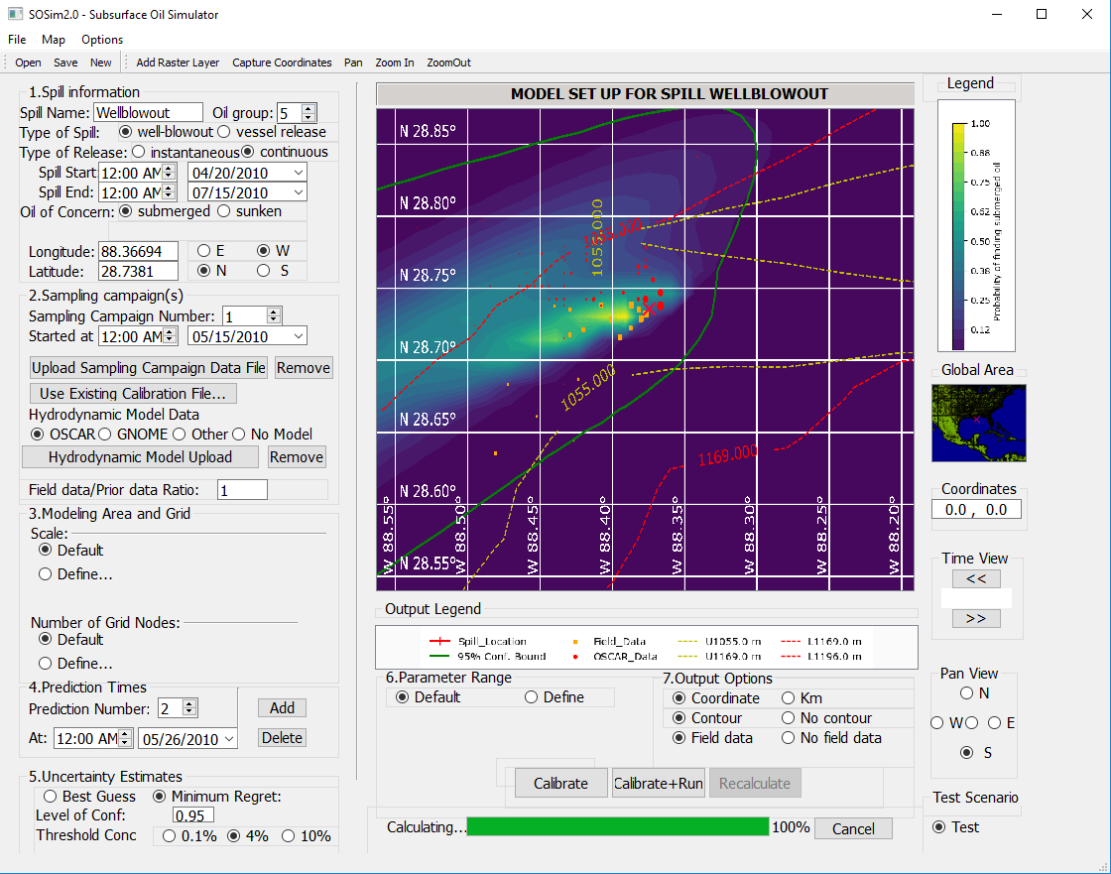

Figure 2: Submerged Oil Model Result for a Well Blowout Spill Displayed in SOSim GUI

Figure 2 is a standard submerged oil output file saved to your desktop. In Figure 2, red circle dots represent prior data and yellow square dots represent field data, with dot size corresponding to oil concentration. The yellow and red contours represent the upper and lower depths of the isopycnal layer containing the submerged oil mass. The green line represents the 95% Conf. Bound on the extent of contamination.

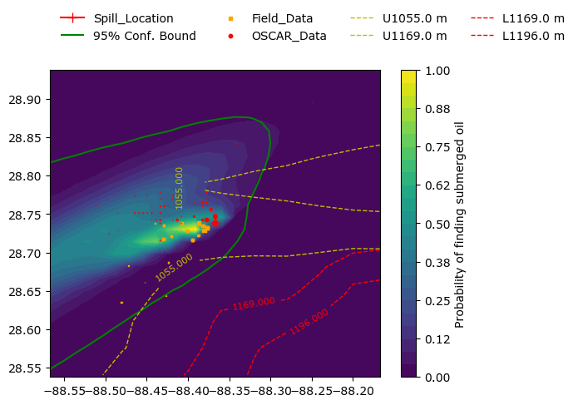

Figure 2: Submerged Oil Model Result for a Well Blowout Spill Saved in Your Folder

* Sunken oil

In Figure 3, results generated by SOSim for sunken oil using data from a vessel release are shown. The GUI shows inputs 1-7 on the left and bottom of the screen shown in Figure 3. The prediction is shown in the middle window. Colored contours represent the relative probability of finding sunken oil, defined in the colorbar on the right side of the screen. The output legend is below the output result. The ‘Global Area’ window shows the location of the study area depicted in the prediction result. To recreate this spill, upload the file “DBL-field-data.csv” for the sampling campaign on November 25, 2005. Also, upload the file “bathymetry-dbl.csv” for the bathymetry data in Decimal degrees.

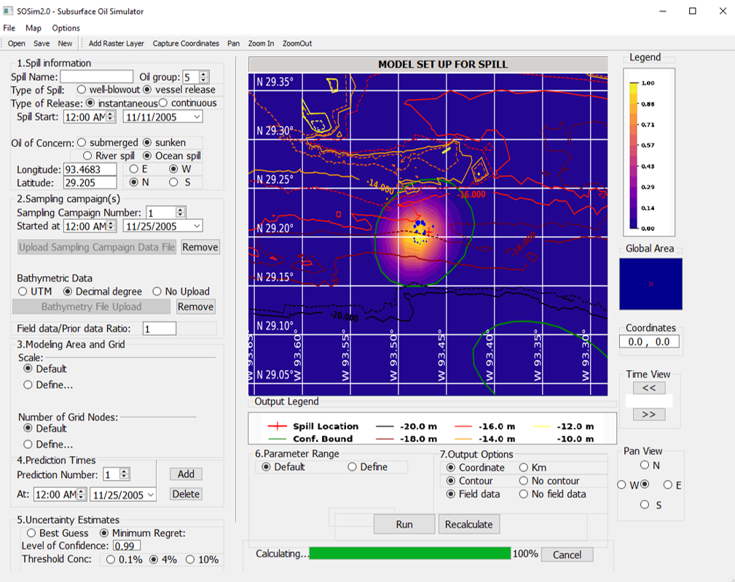

Figure 3: Sunken Oil Model Result for a Vessel Release Spill Displayed in SOSim GUI

In Figure 4, results generated by SOSim for sunken oil using data from a tank barge spill are shown. Blue dots represent field data, with the size of the dot corresponding to oil concentration. Bathymetry is shown as the solid contour lines. The f/H contours are shown in the dashed lines, as it can be expected for sunken oil to primarily follow constant f/H contours. The green line represents the 99% Conf. Bound. Here, prediction time is set equal to the sampling time, because when there is only one sampling campaign there is limited basis for forecasts. Unlike the result obtained with SOSim v.1, which did not have capability to incorporate bathymetric data, these results are consistent with Dr. Beegle-Krause’s assessment following the spill, i.e. that the oil would move with f/H lines and partially disperse in deeper waters, as shown by the uncertainty estimate.

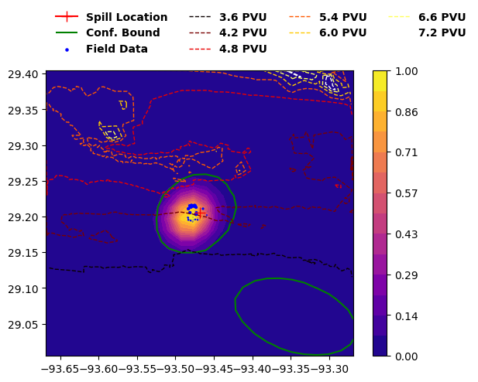

Figure 4: Sunken Oil Model Result for a Tank Barge Spill Saved in Your ‘Results’ Folder

**Contact Information**

Mary Jacketti

Phone: 786-574-1921

Email: [m.jacketti@miami.edu](mailto:m.jacketti@miami.edu)

1251 Memorial Drive

Coral Gables, FL 33146

Chao Ji

Phone: 786-614-5998

Email: [cxj357@miami.edu](mailto:cxj357@miami.edu)

1251 Memorial Drive

Coral Gables, FL 33146

1. SOSim User Manual v. 1.0 cr1 A Guide to Operate the Sunken Oil Mass Simulator.
2. To change an environment variable in a Windows machine, search ‘Edit the System Environment Variable’. In the System Properties box, under “Advanced”, select “Environment Variables” at the bottom. System variables are in the lower part of the box and you only have access to then if you have administrator privileges over the machine. Screen the list to see of the environment variable that you need already exists; if it does, click on it and on “Edit”, then type a semicolon after the existing text and type the given path following, without spaces. If the environment variable does not exist, click on “New” and type the name in capital letters, then the given path.
3. The text in green is what you should write in the Terminal.
4. The text in green is what you should write in the Terminal.
5. The shifted output on the GUI can be fixed in the ‘SOSimsubmerged.py’ or ‘SOSimsunken.py’ codes at the end of the codes using the ‘translation_matrix’.